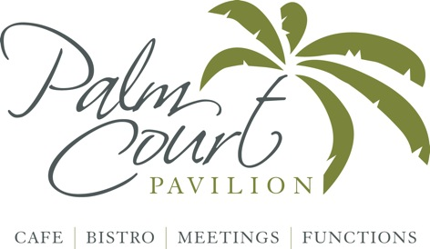

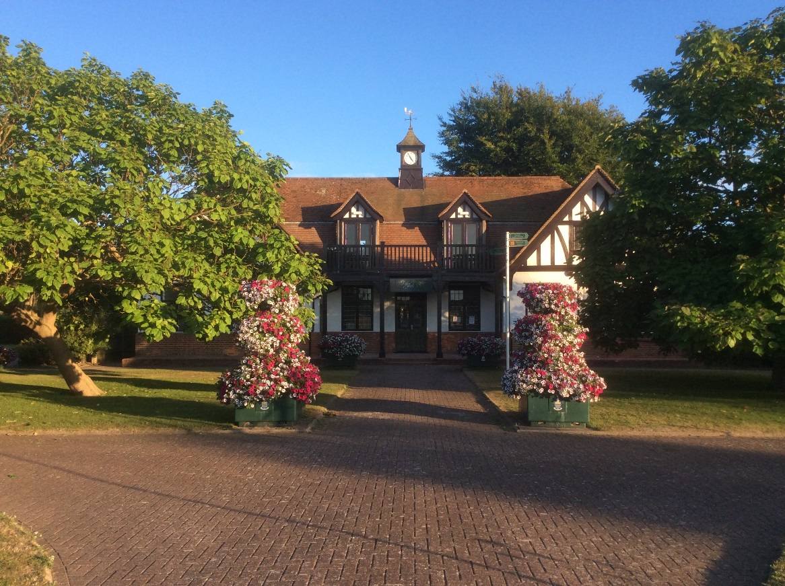

**Function Information & Menus**



**About us**

Nestled in Worthing’s stunning Beach House Park, Palm Court Pavilion is a stylish,

beautifully renovated café-bistro in the park’s Old Pavilion. Located just minutes from

the town centre and the seafront, Palm Court Pavilion serves delicious homemade food

and has a range of options for functions and events.

The cafe is an exciting new chapter in the Pavilion’s interesting history; after some years

in disuse, the Pavilion has been given a new lease of life. The landmark building has been

sympathetically renovated, emphasising the natural light and an extensive outdoor decking

area makes the most of the beautiful park setting. Both areas of decking can be used for

private parties.

The upstairs function room has a balcony giving delightful views of the park and bowling

greens, a perfect venue for parties, meetings and events.

The outside space in the park can also be used for larger scale events of up to 1000 people,

ideal for weddings, dining, exhibitions, corporate launches, markets and roadshows.

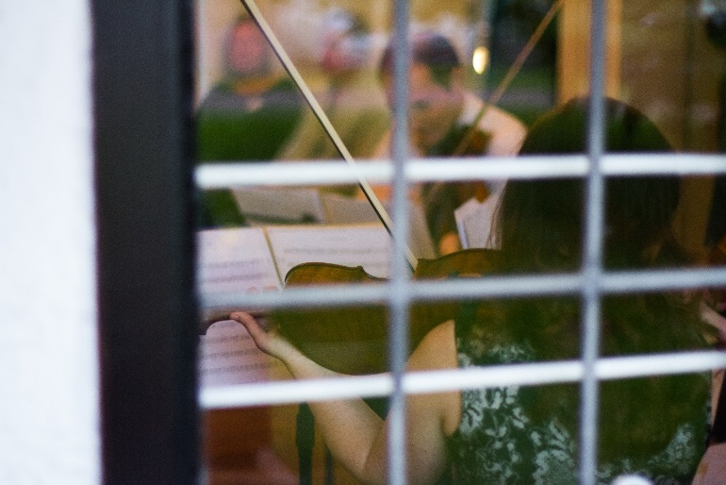

**Room Capacity & Rates**

|  |  |  |  |  |  |  |  |
| --- | --- | --- | --- | --- | --- | --- | --- |
| **Room** | **Park View Room** | **Palm Court** | | **Beech Terrace** | | **Maple Terrace** | **External Marquee** |
| **Daytime – 9am- 6pm**  Monday - Friday  Saturday & Sunday | £200 -£250*  £250* | On request  On request* | | £150*  £250* | | On request | On request |
| **Evening - 7pm-10pm**  Monday -Friday  Saturday & Sunday | £50 – £100*  £250* | On request  £1000* | | £150*  £250* | | On request | On request |
| **Maximum Capacity** |  | | | | | | |
| Board Room | 36 | n/a | n/a | | n/a | | On request |
| Theatre | 60 | n/a | n/a | | n/a | | On request |
| Dining | 40 | 70 | 75 | | 90 | | 75 - 1000 |
| Buffet | 60 | 100 | 120 | | 150 | | On request |

* Prices depend on numbers & menu chosen and will vary by season exclusive of VAT

** Park View Room has a ceiling mounted HDMI Projector for hire.

*** Jan-February lower winter rates apply please call to discuss

Marquee available to hire throughout June and July 2017 call for rates

Sole use of all of the Palm Court is also available upon request

**Parking**

Ample parking available (pay & display every day 8am – 6pm)

Free after 6pm

Disabled parking available upon request

**Park View Room**

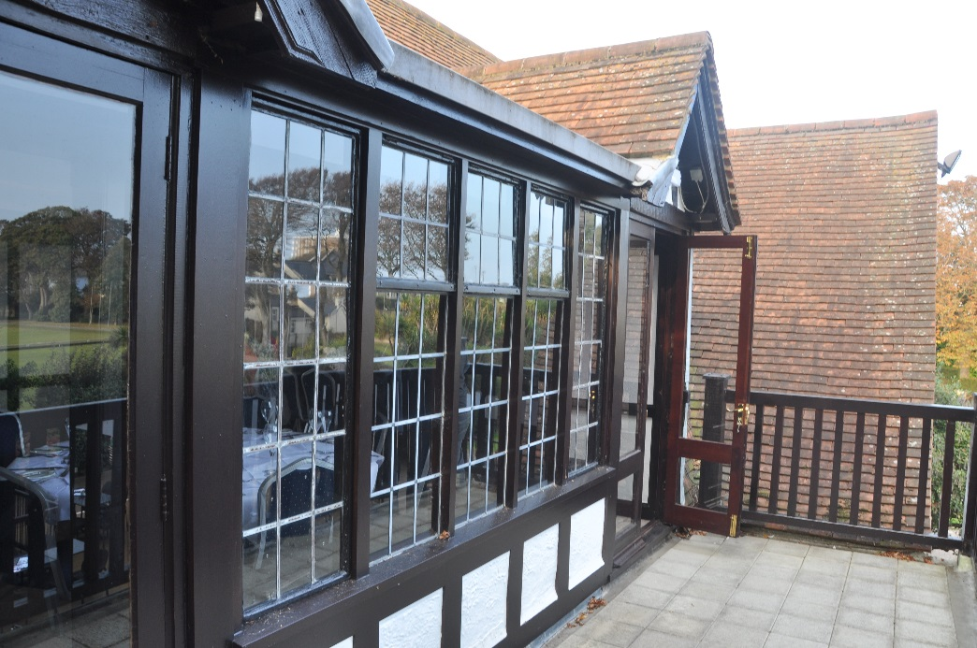

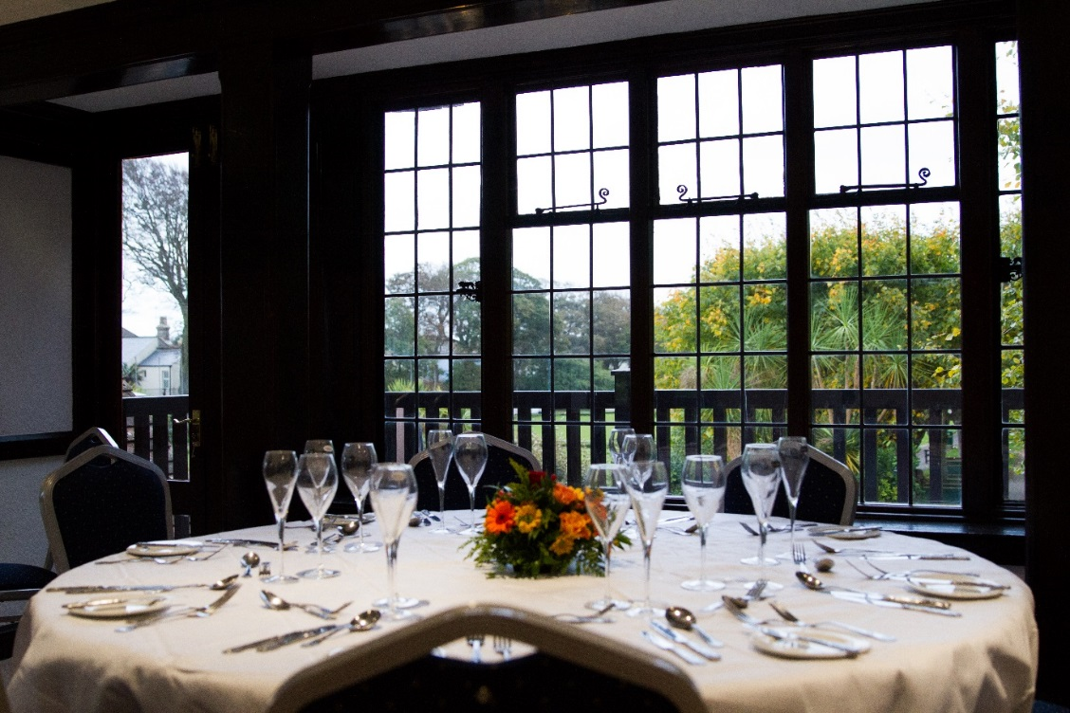

**Palm Court**

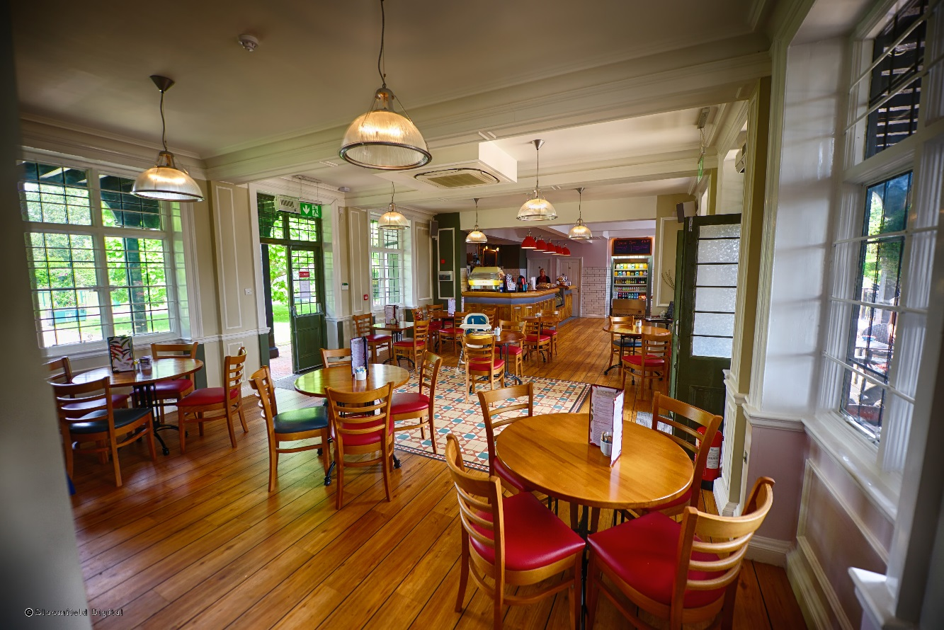

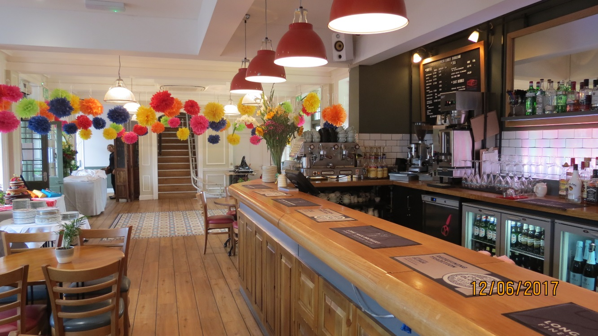

**Maple Terrace**

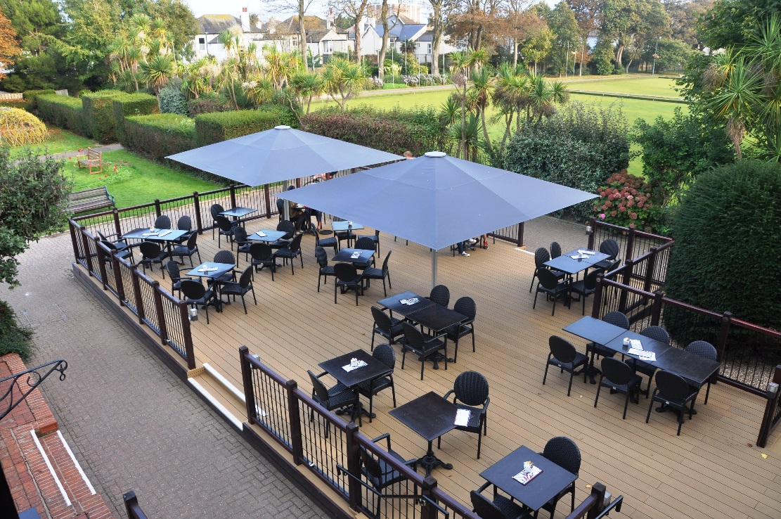

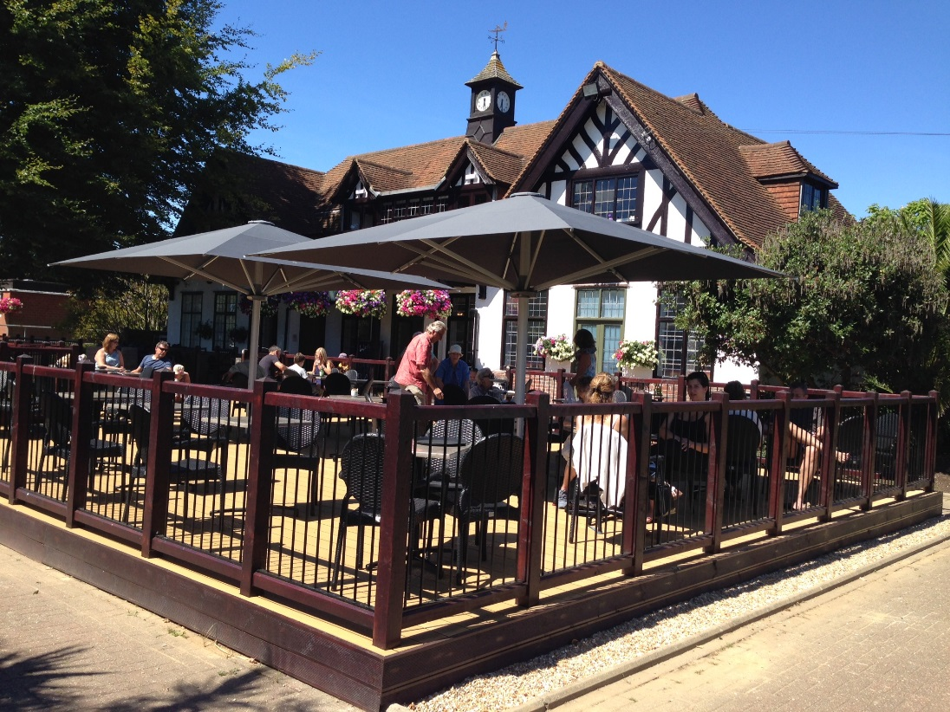

**Beech Terrace**

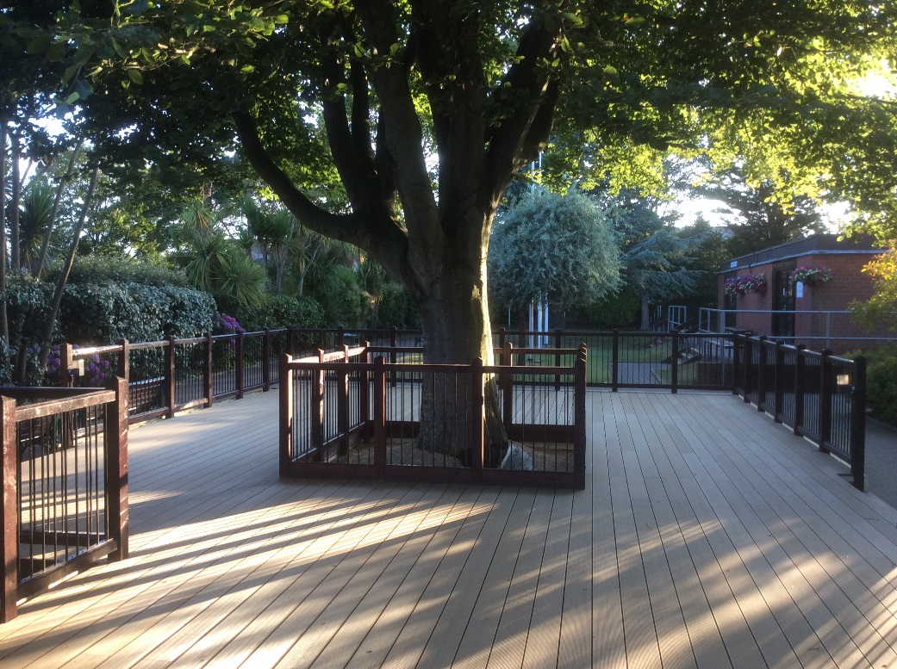

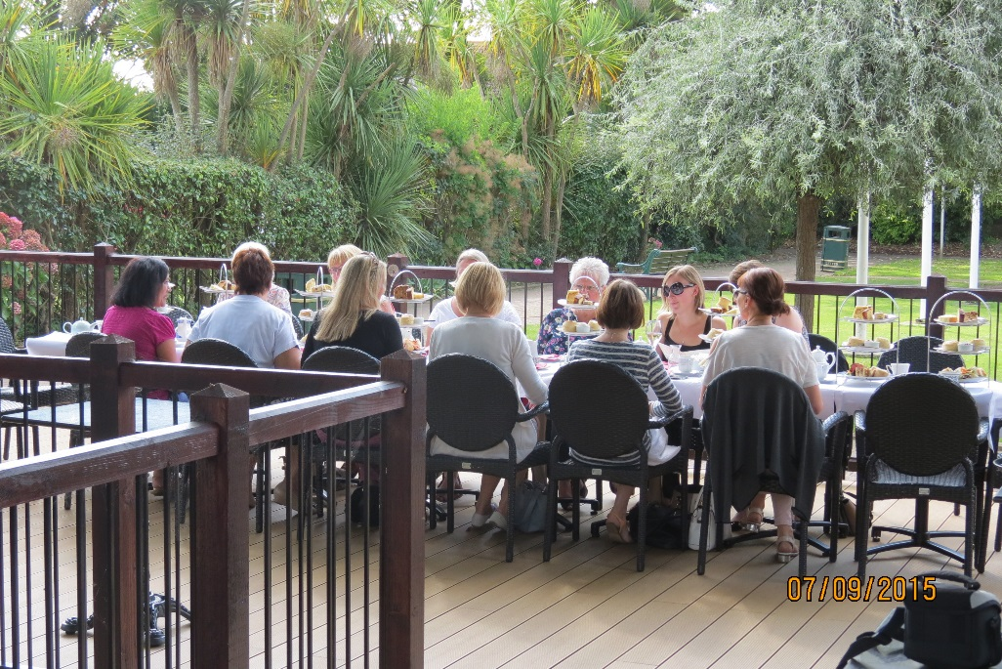

**External Marquee**

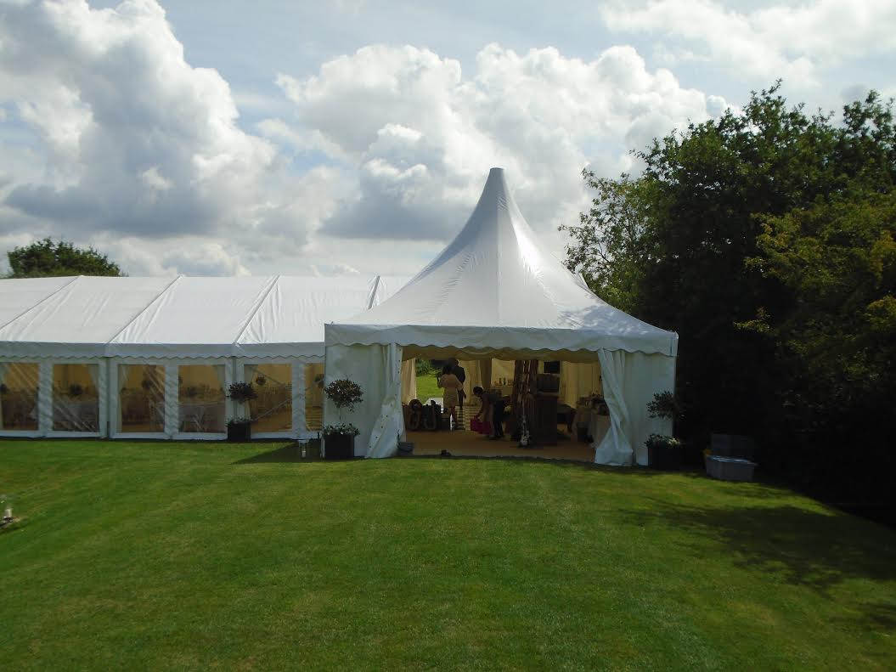

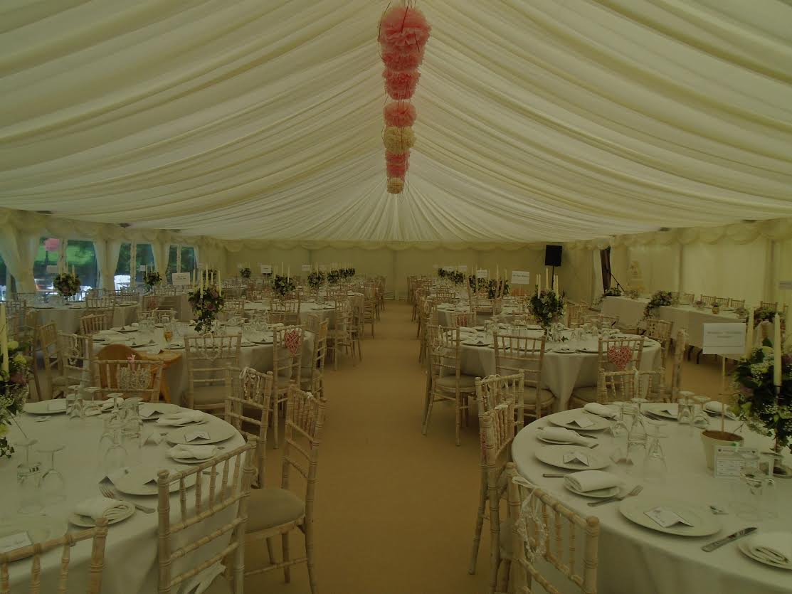

**Banqueting Menu**

**2 Courses from £25.00**

**3 Courses from £29.95**

**Starters**

Smoked salmon, caper and rocket salad

Roasted butternut squash and cumin soup topped with a light mixed herb oil,

with chunky focaccia

Smooth chicken liver parfait with port & brandy served with an apricot chutney

Mozzarella and tomato star with basil pesto

**Main Courses**

Scottish salmon fillet poached in lemon, herb, onion and white wine with Saffron infused potatoes, creamed leeks and spinach, hollandaise sauce

Chicken Breast stuffed with sun blush tomato, wrapped in Parma ham with

diced roasted potatoes, root vegetables and a chicken jus

Portabello mushroom, spinach & blue cheese en croute

**Desserts**

Sharp Lemon Tart with redcurrants and crème fraiche

Warm Chocolate Brownie with clotted cream

Eton Mess

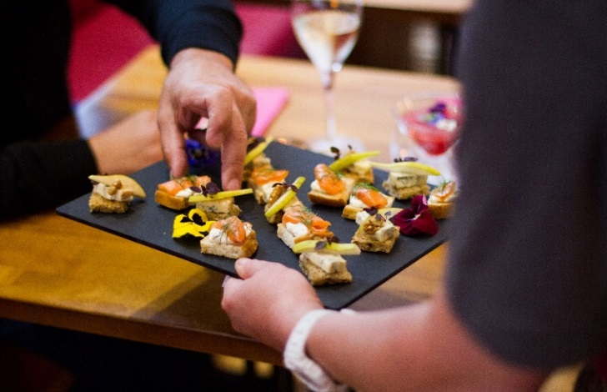

**Canape Menu**

**Cold Canapés**

Smoked salmon & horseradish cream on blini

Pear, stilton & walnut (v)

Coronation chicken on mini naan

Melon & feta skewers (v)

Chicken liver parfait with onion marmalade

Smoked salmon in brioche with dill cream cheese

Wild mushroom crostini (v)

Chicken and lime on foccacia

**Hot Canapés**

Sweet potato frittata (v)

Tomato & feta tartlet (v)

Mini goat cheese parcel (v)

Mini slider burger in brioche bun

Pork and apple sausage rolled in puff pastry

Mini toad in the hole

Mini beef and horseradish

**Dessert Canapés**

Mini scones with clotted cream & jam

Strawberries dipped in chocolate

Mini Bakewell tart

Chocolate mousse served in an espresso cup

Mini Cranachan - Raspberry coulis, cream & oats

Salted caramel brownie

**£9.50 per person (5 items) £12.50 per person (7 items)**

**Hot Buffet Menu**

Build a fabulous colourful display to suit your tastes and requirements.

**Mains**

Beef lasagne with garlic bread and leaf salad

Roast vegetable lasagne with garlic bread and leaf salad (v)

Parmigiana (An Italian dish made with a shallow or deep-fried sliced aubergine filling,

layered with cheese and tomato sauce, then baked) with garlic bread and leaf salad (v)

Mediterranean lamb with rice

Seafood pie with luxury cheese and parsley mash

Moussaka (lamb or vegetarian option) with seasonal greens

Thai green chicken curry with jasmine rice

Pork and apple sausage with mash and onion gravy

Shepherd’s pie with seasonal greens

Chicken curry with poppadoms and basmati rice

Chilli with basmati rice and leaf salad

Mushroom stroganoff with rice and leaf salad (v)

Vegetable curry with poppadoms and basmati rice (v)

Sausage, chorizo and cannellini bean stew with creamy mash

Lemon chicken risotto with leaf salad

Paella a la Valencia with chicken, chorizo and mussels

Bread selection

**Desserts**

Lemon tart

Cheesecake with seasonal fruits

Triple chocolate mousse

Dessert platter - bite size selection of four sweet treats, mousse, lemon drizzle, salted caramel brownie and Victoria sandwich.

**Selection of a main dish and dessert £20.00**

**Selection of two main dishes and two desserts £22.50**

**Selection of three main dishes and three desserts £25.00**

**Evening Finger Buffet Menu**

Selection of filled bridge rolls and sandwiches on artisan breads

Chicken and red pepper skewers

Scotch eggs with piccalilli

Smoked salmon and cream cheese bagels

Potato wedges

Mini goats cheese parcels

Beef satay skewers

Selection of mini quiche slices

Selection of bhajis, pakoras and samosas with mango chutney

Vegetable samosas

Pigs in blankets (chipolata wrapped in bacon)

**3 items £11.00; 4 items £12.25; 5 items £13.50; 6 items £14.75; 7 items £16.00**

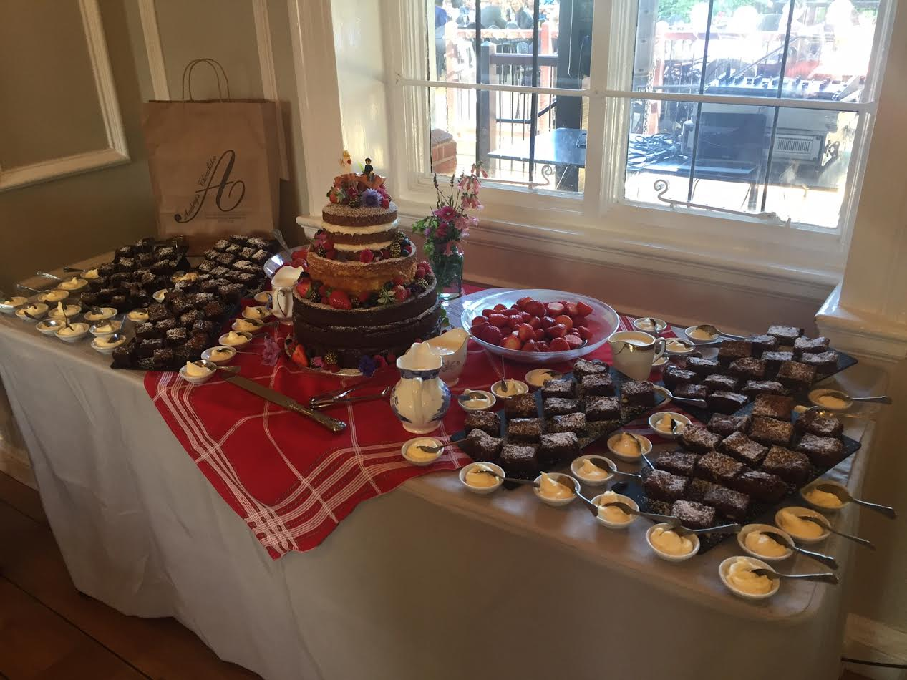

**Cold Buffet Menu**

**Menu A**

Charcuterie and smoked fish platter

Roasted red pepper and halloumi salad

English cheeses with pickles and breads

Platter of Pavilion cake selection

Plus your choice of four salads

**£19.95**

**Menu B**

Poached salmon with lemon mayonnaise

Charcuterie and smoked fish platter

****Trio of parfait platter with meat fish and vegetarian options

Smoked ham with English relishes

Scotch egg with piccalilli and beetroot salad

Platter of Pavilion cake selection

Plus your choice of four salads

**£24.95**

**Salads**

Vine tomato, shaved red onion, balsamic vinegar and baby basil

Nicola potato salad, slice spring onion and creamy mayonnaise

Chargrilled vegetables, bulgur wheat, dried fruit and fresh herbs

Feta cheese, melon and mint

Seasonal leaves

Beetroot coleslaw and fresh herbs

Penne pasta salad with olive garlic basil and tomato

**Daytime events**

Using a private room

Platter of sandwiches using a variety of breads

Platter of homemade cakes **£12.50** per person

**Afternoon Tea** served on a traditional tea stand

with finger sandwiches, warmed scones with clotted cream & jam

together with a selection of cakes & pastries and a pot of tea **£15.00** per person

Add a glass of prosecco **£4.95**

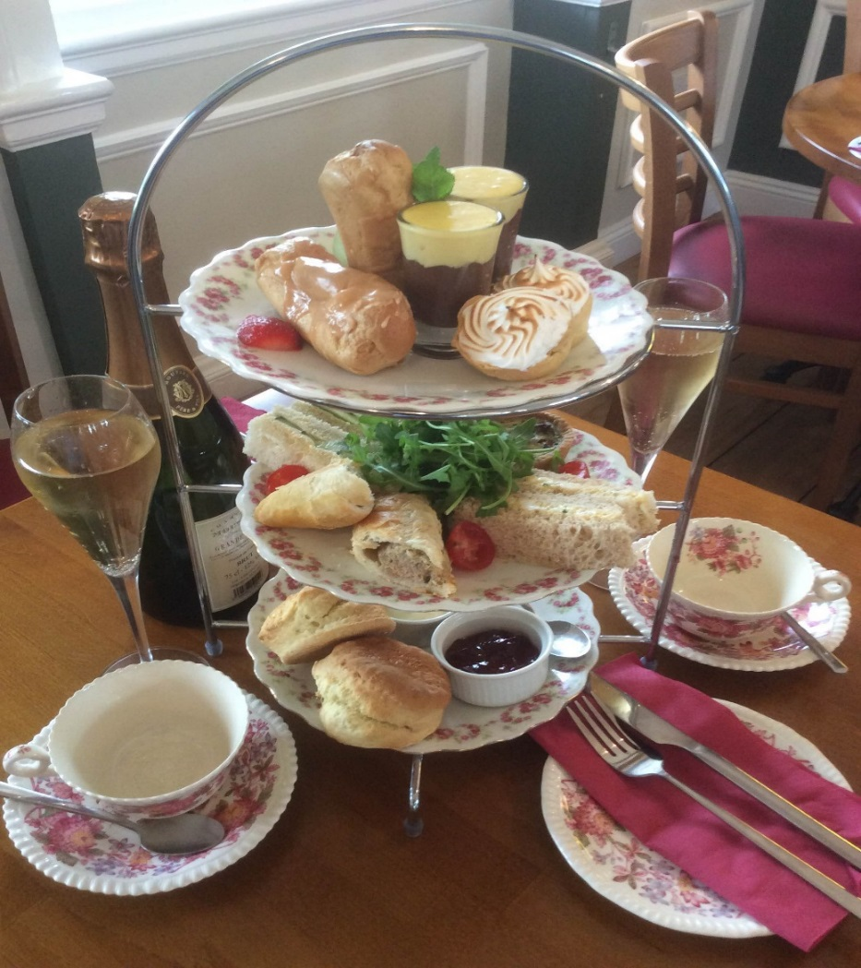

Subject to availability Afternoon tea packages can be tailored to your needs

We can add a range of cocktails and can also theme to requirements.

**Street Food**

**Barbecue**

Chicken kebabs marinated in lime & ginger

Handmade beef burger

Butchers sausages

Spiced lamb seekh kebab

Tiger Prawn, squid skewers marinated in chilli & garlic (£1.00 supplement)

Halloumi cheese, pepper & tomato skewers

Mixed vegetable skewers

Chilli corn cob

Monk fish, chorizo kebab (£1.00 supplement)

Your choice of 4 items with 4 salads and baskets of bread, buns and sauces.

**£17.50** per person

**Pizza**

The dough bases are hand rolled and shaped to approximately ten inch pizza bases or mini individual pizza bases.

Pizza **£ 9.95** per person

- With salads **£12.00** per person

**Paella** Minimum of 50 people

Rich, colourful, flavoursome and cooked in our huge paella pans in front of your guests, we can offer you meat, seafood and vegetarian options. You can choose ingredients such as chicken, chorizo, prawns, mussels, peppers.

Your choice of Paella

Mixed salad leaves, tomato & fresh basil, sliced cucumber, peppers and onion

**£16.50** per person

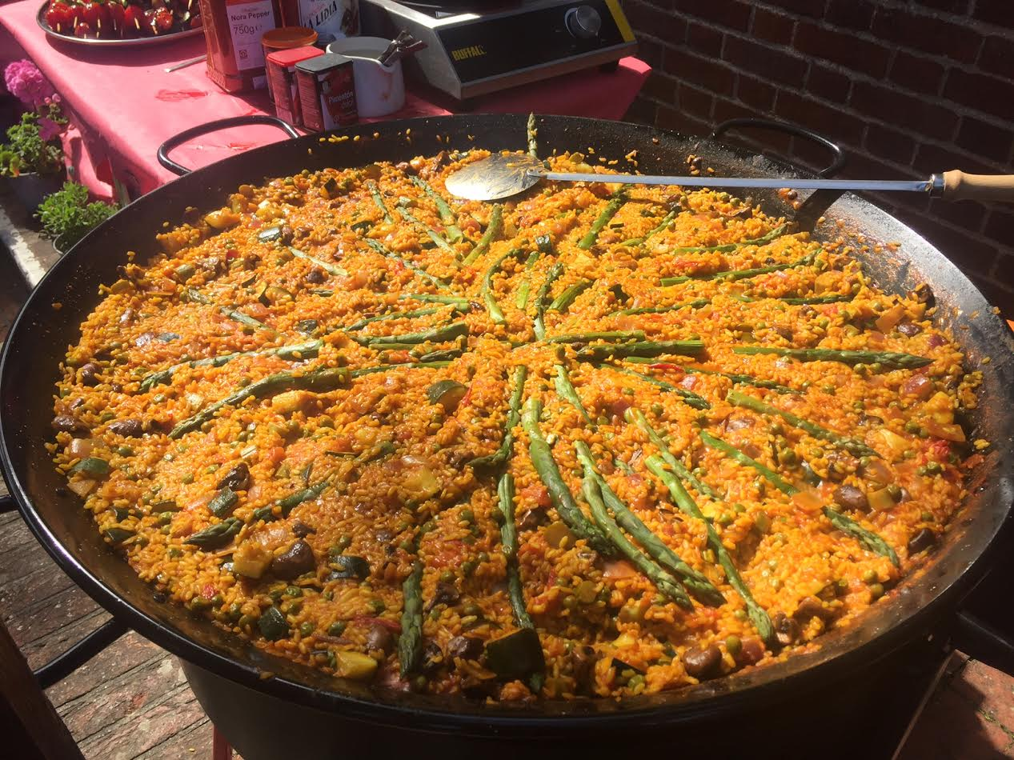

**Delegate Menu**

**Cost per head**

**Continental Breakfast Buffet**  **£6.95**

Cold meats, cheeses, pastries & rolls

Fruit juice, tea & filter coffee

**Lunch Option A £8.95**

Mixed sandwich platter

Fruit platter

**Lunch Option B £12.95**

Mixed sandwich Platter

Warm quiche of the day

Selection of salads

**Lunch Option C £14.95**

Hot dish of the day with accompaniments

Vegetarian dish of the day available

**All menus based on a minimum number of delegates**

**Wedding Information**

Set in the beautiful Beach House Park Palm Court Pavilion gives a stunning backdrop for your special day.

We would be delighted to discuss arrangements for your day and develop a bespoke package

to suit your needs. Please arrange an informal meeting so we can start planning!

Different spaces are available, both inside and outside, depending on your numbers. A private decking area can be arranged and the Park View Room provides an ideal space for smaller groups.

Sole use of the property can be arranged for larger groups and we can organise a purpose built Marquee on the bowling green adjacent to Palm Court for a bigger event.

[](https://www.google.co.uk/url?sa=i&rct=j&q=&esrc=s&source=images&cd=&cad=rja&uact=8&ved=0ahUKEwjfg7HzxPnUAhWDJ1AKHQbdADMQjRwIBw&url=https://www.pinterest.com/jane19720063/clipart-drinks/&psig=AFQjCNH1fabNKUQqNOumKMCKpLrgYH5cXA&ust=1499598183125235)

From a sit down three course meal to a buffet or paella & barbeque on the extensive decking area we can organise the type of day and food choices you would like.

Our Chef is keen to create exciting, innovative and beautiful looking food and will work with you to develop an individual display.

Please note that Palm Court Pavilion is not licensed to perform wedding ceremonies, however you can arrange a celebrant.

**Park View Room**

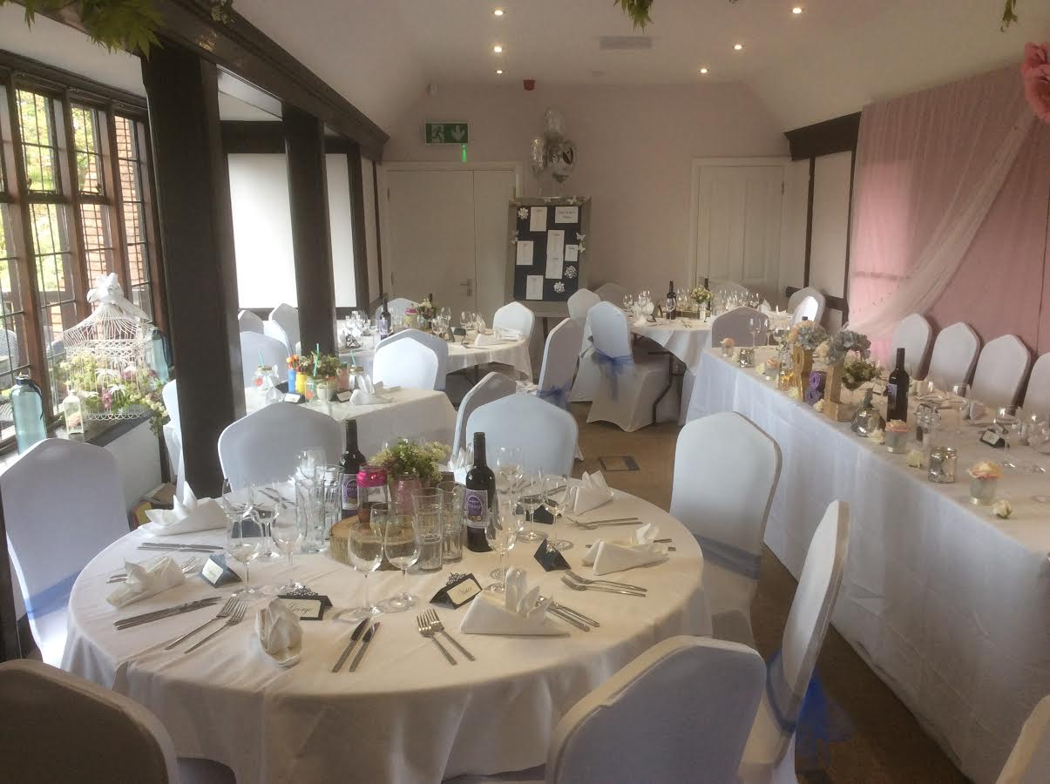

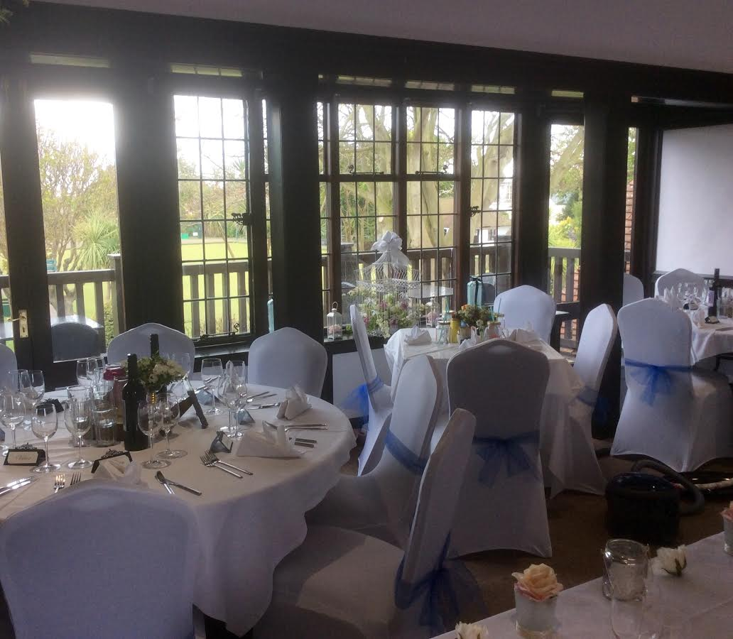

**Beach Terrace**

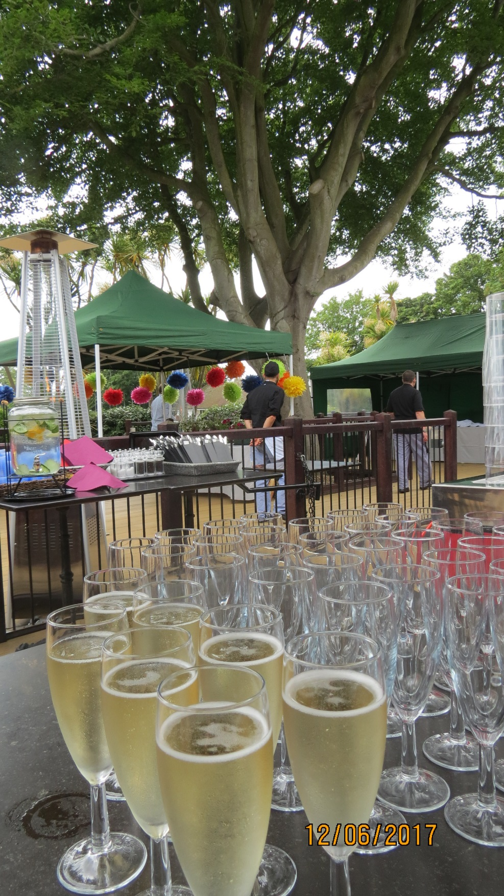

[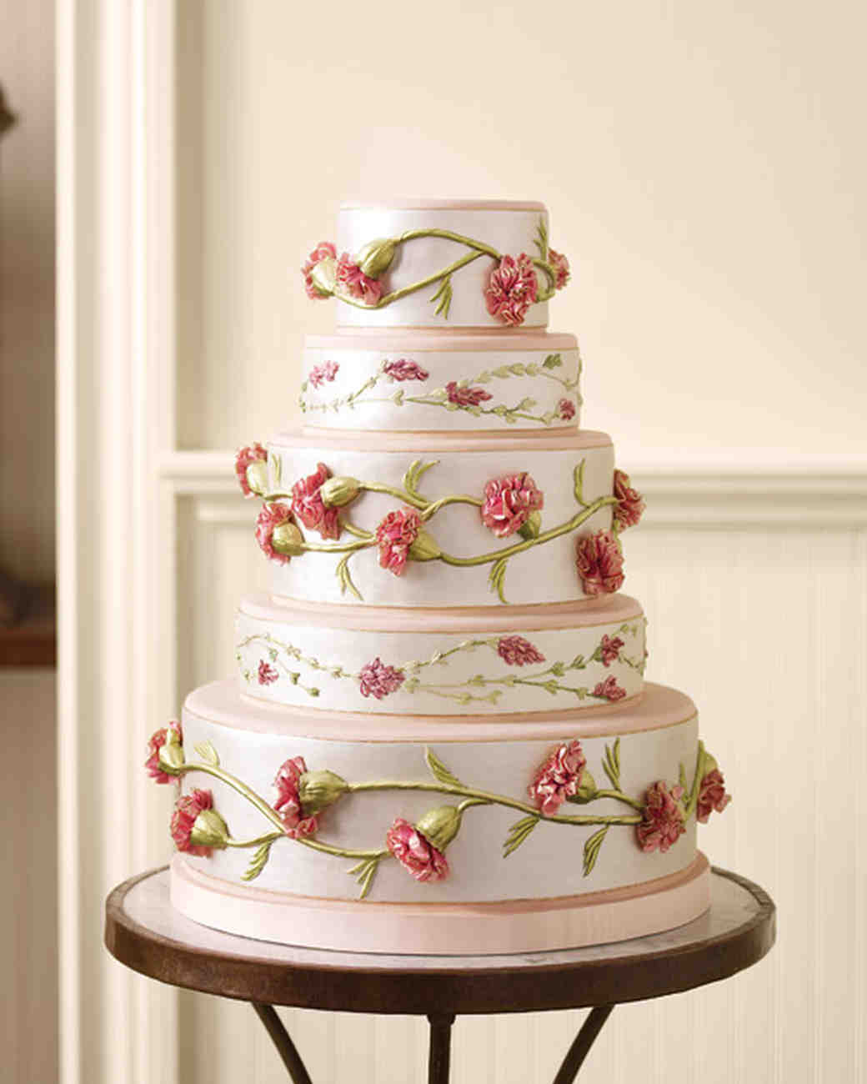](http://www.google.co.uk/url?sa=i&rct=j&q=&esrc=s&source=images&cd=&cad=rja&uact=8&ved=0ahUKEwjBxKTayvnUAhWGL1AKHVlvDyMQjRwIBw&url=http://www.marthastewartweddings.com/231265/50-great-wedding-cakes&psig=AFQjCNEjRpMvWepWDwhKNf1r6Y2HRhT9zg&ust=1499599731580109)

[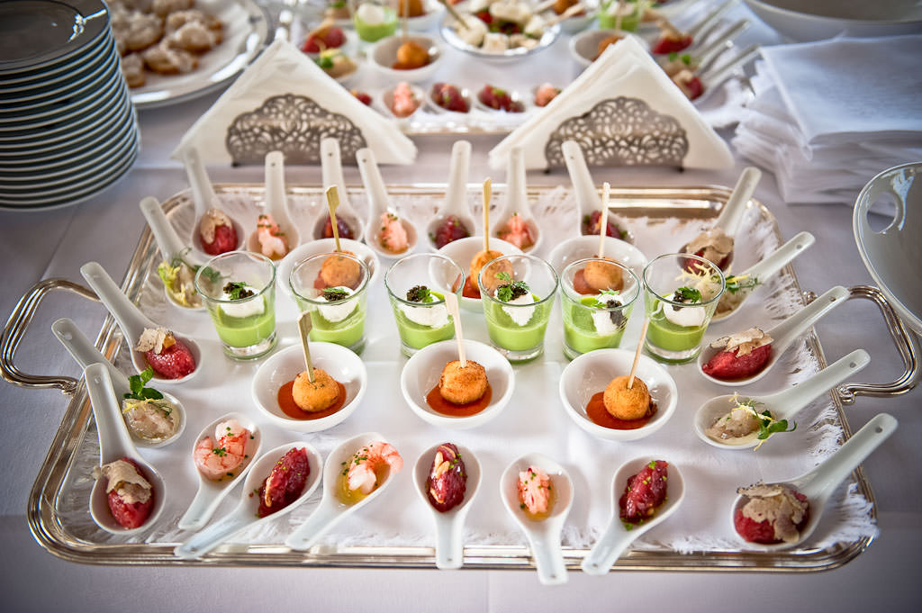](http://www.google.co.uk/url?sa=i&rct=j&q=&esrc=s&source=images&cd=&cad=rja&uact=8&ved=0ahUKEwjq96zYzPnUAhWSmbQKHUnCAIMQjRwIBw&url=http://www.distinctiveitalyweddings.com/blog/2011/09/italian-wedding-receptions-feasting-and-celebrating-italian-style/&psig=AFQjCNHyG02NRHrm8w-6oeoVLEZEYbeP5w&ust=1499599832117409)

[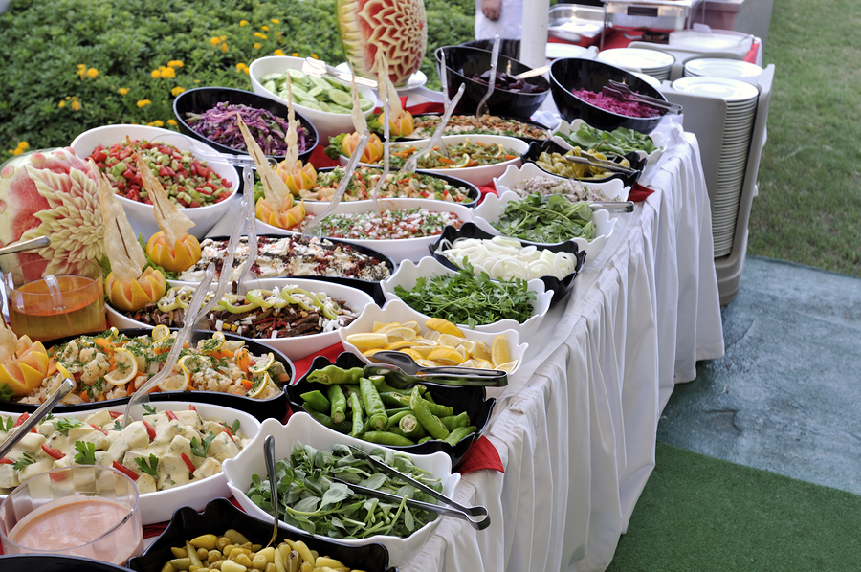](http://www.google.co.uk/url?sa=i&rct=j&q=&esrc=s&source=images&cd=&cad=rja&uact=8&ved=0ahUKEwjvtsSF__vUAhXLKlAKHbWEBvEQjRwIBw&url=http://sandwichbuffet.co.uk/2014/02/10/local-wedding-catering-london/&psig=AFQjCNHR_1bq-CovYL02x65-8PKVLhfKCg&ust=1499682552770782)

**Dessert Buffet**



**Terms & Conditions**

**VAT** All prices shown are inclusive of VAT except room hire.

**Booking and confirmation** If you wish to proceed with the booking, we will issue an invoice for a non-refundable 25% of the agreed total. The booking is not confirmed until the booking form has been returned and the 25% deposit has been received. The remaining balance, including any agreed drinks packages, is due 14 days prior to the event date. Final numbers are to be confirmed 7 days prior to the event. Any amendments to the booking must be confirmed in writing and no less than 28 days before the event.

**Cancellation** The deposit is non-refundable in the event of cancellation. If an event is cancelled less than four months prior to the scheduled date then full payment for the planned event is due.

**Access** The premises will be available at the time specified on the booking form. Access to decorate the room can be arranged during Palm Court’s normal opening times, please check with the Duty Manager.

**Decorations** Bunting, balloons and banners are welcome using blutac to secure. Mini glitter and confetti is not permitted inside or outside the building. Smoke/Bubble machines or pyrotechnics are not permitted on any part of the premises. No alterations or additions to fixtures, fittings, lighting or heating are permitted.

**Use of premises** The use of the premises must be as indicated on the booking form. Gaming is not permitted on the premises. The premises shall not be used for any illegal, immoral or other purpose that could breach any legislation or regulation, or that could jeopardise any insurance cover in respect of the premises.

**Damage** The organiser shall take all precautions to prevent damage, and shall defray the cost of making good any damage caused to the premises or any theft or loss of goods or appliances belonging to Palm Court during the event or directly connected to the event.

**Behaviour** Palm Court will not tolerate discriminatory, offensive or abusive behaviour by any group or individual, and reserves the right to terminate or cancel an event if this condition is breached. During the event, all persons on the premises must comply with any directions of the Duty Manager regarding proper use of the premises and items brought onto it. Palm Court Pavilion shall, at its absolute discretion cancel or terminate an event if damage to the venue is considered likely or has occurred in connection with the event. In such cases, the organiser shall still be liable for the full cost of the event.

**Personal property** No items are allowed or stored on any part of the premises outside the event times as detailed in the booking confirmation. All items left on the premises after an event will be deemed unwanted and disposed of without notice. Palm Court Pavilion does not accept any responsibility for damage, loss or theft of any property left on the premises at any time.

**Catering and drinks** Palm Court does not permit any external catering companies within the park. Under the terms of our license we cannot permit any persons to provide or consume any beverages (alcoholic or otherwise) that have not been purchased on the premises. We will not be held liable under any circumstance for the quality or hygiene of any self-catered food served on the premises.

**Crockery and Glassware deposit** For outdoor events a deposit of £200 will be required to cover any broken or missing china or glassware. The deposit will be refunded, less any deductions to cover broken or missing items, after the event.





